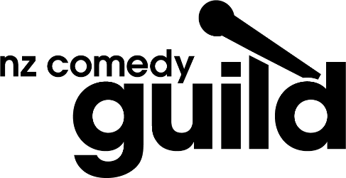
20 December 2017 – The 2017 NZ Comedy Guild Awards last night celebrated New Zealand’s talented comedy stars.
“The nominees and winners in the 2017 NZ Comedy Guild Awards continues to showcase the best and brightest in Aotearoa’s diverse and thriving comedy scene. Across the growing range of mediums online, on television, in film, print and radio, our comedians are not just doing a great job of reflecting our kiwi humour back at us, but increasingly bringing our brand of funny to rest of the world.” said Debs McSmith, Chair of the NZ Comedy Guild.
The Classic comedy club on Auckland’s Queen St, which this year celebrates its 20th year, hosted a brilliant night of laughs and celebration. 2016’s Best MC winner, Justine Smith hosted the evening of awards, which were decided by NZ Comedy Guild members and an industry panel.
The NZ Comedy Guild was established in 1999 and has been representing the interests of New Zealand comedians ever since. The annual Comedy Guild Awards, or “Guildies” as they are affectionately known, are a highlight of the year for the whole community and are a great illustration of just how far the industry has come over the years.
Below are winners for this 2017, the full list of nominees can be seen at the Guild’s website, http://www.comedyguild.org.nz/2017-guild-awards.html

Best Male Comedian
Guy Montgomery
Best Female Comedian
Justine Smith
Best MC
Rhys Mathewson
Breakthrough Comedian of the Year
Melanie Bracewell
Outstanding Artist Achievement (The Kevin Smith Memorial Cup)
Taika Waititi
Best Newcomer
James Mustapic
Gag of The Year
Fan Brigade
Best Improv Show
Snort
Best Live Show
Rhys Mathewson
Best International Guest
Ray Badran
‘The Classic’ Best Comedy Venue Award
Basement Theatre
Outstanding Contribution to The Industry
Brendhan Lovegrove
The Green Roomer
David Correos
Comic Originality
David Correos and Tom Sainsbury (tie)
Best Writer – Live Performance
Nick Rado
Best Comedy Performance on Television
Josh Thomson
Best Comedy TV Series or Event
Funny Girls
Best Comedy Writing for Film or Television
Taika Waititi
Most Offensive Gag (The Andrew Kovacevich Memorial Cup)
James Malcolm and Lucy Roche (tie)
Best Comedy Web Series, Podcast or Radio Series
Tom Sainsbury
Funniest Twitterer
Lauren Mabbett
Funniest Blog/Column
Raybon Kan
Funniest Online Presence
Tom Sainsbury

ENDS

