Recommended pay rates for live comedy

- Introduction
If you’re booking a comedian, you’re probably going to benefit from their skills, effort and experience. Maybe you’ll make money from tickets or drink sales, or you’ll impress guests at your corporate event. Perhaps the comedian’s public profile will attract new customers to your business. Whatever the benefit will be, there’s a reason you want a comedian to perform, so there is value in that performance. And just like plumbers, lawyers and checkout operators, comedians deserve to be paid for what they do for you.

Two key principles to keep in mind when planning/budgeting for a comedy show are:
- The show should be value for money for the audience: that is, the quality of the show should match or exceed the audience's expectations based on the ticket price, marketing material etc.
- The show should offer something to each performer. Depending on the type of show, this could be:
  - Payment at or above the rates specified in this document.
  - A chance to workshop new material in a relatively low-stakes environment where audience expectations have been set at an appropriate level. Practicing and refining new material is critical to comedians' development and performers should be free to do this to some extent whenever they are not being paid at or above the Guild rates, unless explicitly agreed otherwise, (and exceptions should be rare).
  - Less commonly, some combination of payment and a chance to try new material.

The NZ comedy industry is extremely diverse. The appropriate pay rate for a comedian will depend on the comedian’s experience, profile and skill, the type of performance, the venue capacity and ticket price - even the region the performance will take place in. The following guidelines are recommendations that have been developed in consultation with the comedy industry. While every gig is different, in all but exceptional circumstances these rates represent what we consider a reasonable ‘minimum wage’ for professional comedians.

Table 1 - Summary of minimum rates for different performance types

Type of show | Minimum rate | Comments
Standard live performances | $12/min | This is the minimum rate set by the Guild for a professional performance. A more detailed schedule of rates for specific situations is given in Figure 1.
Corporate performance | $90/min | This can vary greatly depending on the comic’s profile and the company involved. This should give a comedian an understanding of where to negotiate from.
Televised performance | $600/min | Per broadcast minute. Calculated per minute or part thereof for first 4 minutes, and in 15 second increments for longer sets.
All rates exclude GST, but include any other applicable taxes.

Why those rates? When a comedian gets paid for a performance, they’re not just getting paid for that minute of performance, they’re also getting paid for the hours they spent writing and rehearsing the material and often the years they’ve spent building up their public profile. It’s worth noting that experience does not necessarily imply talent, and conversely a lack of experience does not imply a lack of talent. Talent and experience also doesn’t mean a comedian will be suitable for every environment. Do your research and get to know the comedian before booking them. If you’d like more advice, contact the NZ Comedy Guild by emailing admin@comedyguild.org.nz

3. Standard live comedy shows
3.1 Summary
There are a wide range of live comedy shows, from open mics with a handful of punters to gala-style shows with an audience of thousands. Audience expectations vary significantly. In these guidelines, shows are broken into three categories based on ticket price:

Table 2 - Categories of live comedy show (excluding corporate)

Category | Ticket price | Payment for performers | Expectations of performers
Open mic | Less than $10 (including koha/free) | MC: $150  Other acts: unpaid | MC: welcome/warm up audience, mixture of tested & new material & crowdwork.  Unpaid spots: new/untested material.
Semi-pro | More than $10 but less than $20 | MC: $200  Other acts: paid at a lower rate, or only some acts paid (e.g. headliner only)  See section 3.4 | In between open mic and pro show expectations, depending on pay. See Section 3.4 of the full document.
Pro | $20 to $35 or higher | MC: $300  Other acts: $12 or higher per minute. See figure 1 for more guidance | High standard of performance (i.e. “gold” material) expected from all acts

Venue size is also an important factor. A $20 show in a very small venue may be semi-professional, while a $10 show in a very large venue should typically be fully professional.

Note that profit share shows are discussed separately in Section 3.6.

The budgets on which the rates are based are attached. Note that these assume shows are funded entirely from ticket sales and that the producer’s pay is the show profit, rather than a producer’s fee. When organising shows that are funded in other ways (e.g. bought by a venue for a fixed price), be sure to include a producer’s fee in the budget.

3.2 Professional shows
The minimum rate of $12/min applies to all performers in a professional comedy show. For shows in larger venues (>120 seats) and with higher ticket prices, it is expected that this ‘floor’ will rise accordingly, as per the flow chart below.

Ticket prices referred to in the figure are pre-sale prices excluding booking fees. For 'dinner and show' tickets or similar package deals, the show only price should be used (or a reasonable estimate of it). We also acknowledge that producers may not always be in control of ticket prices, such as where a venue buys a show.

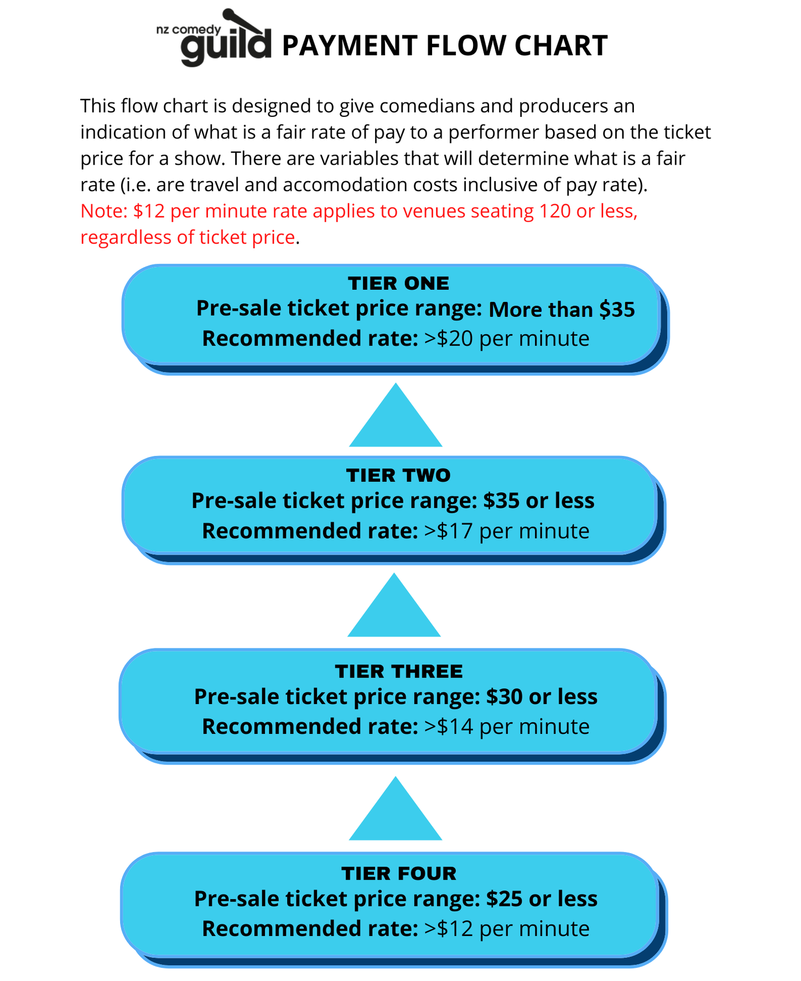

Again, these represent a minimum for each tier and highly experienced or high profile performers may expect a higher rate. It is assumed that travel and accommodation costs will be met by the producer. The NZCG acknowledges that there are some circumstances (e.g. shows in very small venues or in the regions) where payment at these rates may not be financially sustainable, but these should be the exception, not the rule. Conversely, for very large venues (significantly larger than 120 seats), higher rates would generally be expected.

3.3 Open Mics
The Guild recognizes that the benefit transaction is slightly different for Open Mic events. These events often offer emerging comedians valuable stage time that will help them refine their material and improve their stagecraft. For this reason, it is acceptable to offer performers complimentary food and/or beverage in lieu of a fee. The Guild also recommends clearly communicating the level of performance the audience can expect at an Open Mic night to avoid disappointment and to provide a safe and supportive environment for emerging comedians.

Likewise, the entry fee for audiences should be reasonable and commensurate with the level of performance (generally no more than $10).

3.4 Semi-Pro shows.
The term semi-pro is broad and contains grey areas but in general refers to a show where comedians and audience should expect a higher calibre than an open mic but comedians are not expected to to do their “gold” material. They generally take place in smaller venues with lower ticket prices (<$20) where it may not be feasible to pay guild rates to every performer and still produce the show. In general, all shows with a ticket price of $20 or over should be fully professional (i.e.all acts paid at Guild rates or higher), and exceptions should be limited.

Semi pro shows can be broken into two categories.
- Everyone is paid at a reduced rate. E.g. $50 for 10 minutes. In an instance like this comedians should do some well-tested material but are also not required to spend their entire set doing “gold” material and are encouraged to try newer partially tested material. For example 5 minutes of gold and 5 minutes of newer material. A good rule is if you are being paid any amount you should be doing the job that sum reflects.
- Shows where some acts are paid and others are not. These shows are often part way between an open mic and a pro show where the MC and headliner are being paid while the spots are unpaid. In this situation payment to those acts should be at or above the minimum rate of $12/min.

In both categories, it is important that audience expectations are managed to an appropriate level by the promotional materials and the MC’s introduction. Promoting shows in either category as “professional” (without any qualification) will result in underwhelmed audience members and this is damaging to both the show itself and the wider industry. Also, in general, we don’t recommend using the names and images of performers who aren’t being paid to promote the show, as this creates an unfair expectation from the audience that they will be seeing this performer at their best.

Performers who are not being paid should not be required to do any “gold” material and should treat the show as an open mic where they can work on new material while maintaining the professional standard they set for themselves. A free drink or contribution towards transport costs does not count as payment.

Performers who are being paid, especially to MC or headline, should ensure the pay rate is commensurate to the type of show, the ticket price, size of venue and whether their name or brand are being used to help sell tickets. These are all factors to take into account especially if payment is below the guild recommended rates.

3.5 MCing
As with other performers, rates for MCs vary depending on the event, the experience of the comedian hired to host the event, and the amount of time required of the MC. In general MCs should be paid based on a reasonable estimate of the stage time required from them, which may vary quite a bit between shows of the same general category. The following minimum MC rates are considered reasonable:
- Open mics: $150. It is important to note that the MC at an open mic is generally the only act being paid and therefore the only act expected to be performing “gold” material.
- Semi-pro: $200
- Pro show: $300

For hosting corporate shows, the fee may vary considerably due to different formats, the amount of stage time required, as well as the profile and experience of the performer. In general though, $1,000 is a reasonable minimum fee for corporate hosting, while significantly higher fees will often be reasonable depending on the circumstances.

3.6 Profit share shows
In some cases, comedians' pay is not a fixed fee, but is based on the financial success of the show (either calculated from the profit, or the number of tickets sold). There are two common scenarios where this occurs:
- A group of comedians work together to produce and perform a show (such as a festival lineup show) and agree to share the profits, or any loss between themselves,
- A promoter (who may or may not be a comedian as well) books one or more comedians to perform in a show and offers to pay them on a profit share basis, rather than a fixed fee.

For scenario 1, all performers participating in the show should explicitly agree when planning the show on how profits will be shared (especially if not an even split) and how much will be spent on venue hire, sound and lighting, promotion and any other expenses required. This avoids disputes later on about which costs should be included. The best way to do this is by writing a show budget together and getting a mutually agreed on written contract prior to the show.

For the second profit share scenario, where some or all of the comedians performing are not involved in organising the show, the guild strongly recommends that:
- Producers must provide enough information in writing to enable performers to roughly estimate the likely range of fees and make an informed decision about whether to accept the gig. The information provided should include the capacity of the venue, ticket price, what expenses will be deducted before calculating the profit share, and what percentage of the profit each act (and the producer) will earn. It is not acceptable for a producer to offer a performer a gig and state that they'll be paid as a profit share with no further information.
- Performers on a profit share show who are not involved in producing/promoting the show have no liability for any loss.
- Similarly, performers' direct expenses (such as transport to the show or accommodation for out-of-town gigs) should be included as part of the show budget, rather than performers being expected to meet these costs from their share of the profit.
- If the show sells out (or is close to it), the profit share earned by the performers should generally exceed the standard guild rates for the length of their set. This is because profit share shows involve the performers taking on some of the risks associated with the show (potentially including the risk that sales will be poor and they won't be paid at all), and therefore they should also share in the benefits when shows sell well.

3.7 Charity events
Comedians are frequently approached to donate their time and talent in support of a charity. But before you ask a comedian to perform for free, check what you are expecting from other supporters. Are you working for free? Are any other performers or celebrities? Are the lighting and sound technicians? The chefs? Unless the answer is yes, it’s unfair to ask a comedian to be the only one working for free.

4. Corporate shows
Corporate events incur higher rates than standard gigs, mainly because the expectation of the client and the effort required from the comedian are much higher. Often, the comedian is expected to edit their material, language and tone, and dress more formally. Corporate events can also be more challenging than standard gigs, as oftentimes the audience hasn’t chosen to be there.

As above, rates will depend on the comedian’s experience, talent and profile, and also on the venue/audience size, the location, etc. A minimum rate for corporate performance should be $90 per minute. Again, highly experienced and high-profile comedians may expect significantly more than this. This rate is given as a guideline for performers to negotiate from.

5. Televised performances
Televised performances require an even higher standard of performance and preparation by performers, due to the much larger audience. In addition, many comedians retire material after televised performances, and payment must reflect their limited ability to use that material (typically among their best material) after the show is televised.To reflect this, the minimum rate of payment for televised performances is significantly higher: $600 per minute. This is paid per broadcast minute (or part thereof) for the first 4 minutes, and in 15 second increments for sets longer than 4 minutes.

6. Payment
The Guild does not endorse ‘cash’ jobs. As a comedian you should ensure you are provided with a contract that states all important information including set length, performance fee, code of conduct, payment timeframe etc. As a producer you are expected to provide a contract and code of conduct to all performers which should be agreed upon and signed by both parties.This is especially important for corporate or televised shows.

The guild recommends a payment deadline of 10 working days of the invoice being sent unless otherwise agreed.

The New Zealand Comedy Guild has template contracts, invoices and code of conduct documents here.

7. Applicability and enforcement
While NZCG is not a regulatory authority, our expectation is that:
- By default, producers should offer comedy performers a fee which is in keeping with the rates specified in this document, taking into account the ticket price for the relevant event.
- Performers should expect this, and where Guild rates are not offered initially, discuss this with the producer to educate if required, and find out why a lower rate has been offered.

We encourage performers to be reasonable in genuinely exceptional circumstances, but also to recognise their value and ask questions. Performers should also consider the effect on their fellow comedians of accepting shows at below guild rates - there is power in solidarity, and ultimately these recommendations will be upheld by the comedy community as much as by the Guild itself. We also encourage performers to openly discuss performance rates with each other, both in general terms and in relation to specific shows, venues or producers. Do not sign a contract which restricts your ability to do this without seeking advice first.

Whenever a producer offers a performance fee which is lower than the relevant rate set in this document, the onus is on them to justify this to performers. This includes answering reasonable questions about the likely costs and income associated with the event. Producers in this situation must also accept that performers are unlikely to deliver their “gold” material when they are not being paid for that standard of performance.

Every paid performance involves a contract between the performer and producer and ultimately only they as individuals can decide the terms they are willing to accept. However, barring exceptional circumstances, the rates in this document are considered fair to all parties and should be followed. NZCG will investigate complaints regarding late payment or underpayment. Any allegations of “blacklisting” or other recriminations against performers raising concerns regarding payment will be taken particularly seriously.

